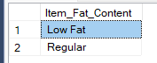
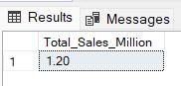
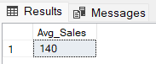
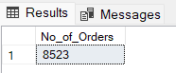
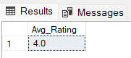
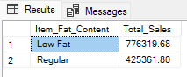
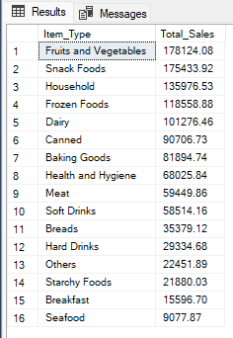
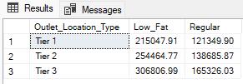
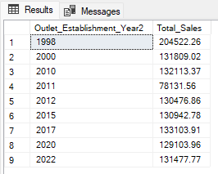
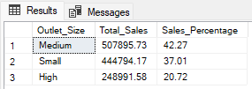
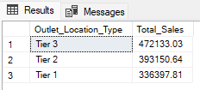
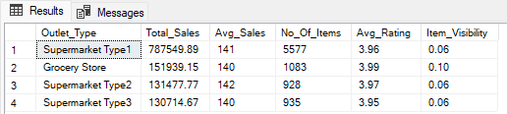
Blinkit Analysis
- See all the data imported:
SELECT * FROM blinkit;
- DATA CLEANING:
Cleaning the Item_Fat_Content field ensures data consistency and accuracy in analysis. The presence of multiple variations of the same category (e.g., LF, low fat vs. Low Fat) can cause issues in reporting, aggregations, and filtering. By standardizing these values, we improve data quality, making it easier to generate insights and maintain uniformity in our datasets.
UPDATE blinkit
SET itemfatcontent =
CASE
when itemfatcontent in ('LF','low fat') then 'Low Fat'
when itemfatcontent = 'reg' then 'Regular'
else itemfatcontent
END;

After executing this query check the data has been cleaned or not using below query
SELECT DISTINCT Itemfatcontent FROM blinkit;

A. KPI’s
1. TOTAL SALES:
select cast(sum(totalsales)/1000000 as decimal(10,2)) as

Total_Sales_Million from blinkit;

2. AVERAGE SALES
SELECT CAST(AVG(Total_Sales) AS INT) AS Avg_Sales
FROM blinkit;
3. NO OF ITEMS
SELECT COUNT(*) AS No_of_Orders
FROM blinkit;
4. AVG RATING
SELECT CAST(AVG(Rating) AS DECIMAL(10,1)) AS Avg_Rating
FROM blinkit;

B. Total Sales by Fat Content:
select itemfatcontent,round(sum(totalsales),2) as total_sales
from blinkit
group by itemfatcontent
order by total_sales DESC;

C. Total Sales by Item Type
select itemtype,cast(sum(totalsales) as decimal(10,2))as Total_Sales
from blinkit
group by itemtype
order by Total_Sales DESC;
D. Fat Content by Outlet for Total Sales
SELECT outletlocationtype,
round(SUM(CASE WHEN itemfatcontent = 'Low Fat' THEN totalsales ELSE 0 END),2) AS Low_Fat,
round(SUM(CASE WHEN itemfatcontent = 'Regular' THEN totalsales ELSE 0 END),2) AS Regular
FROM blinkit
GROUP BY outletlocationtype
ORDER BY outletlocationtype;

E. Total Sales by Outlet Establishment
SELECT outletestablishmentyear,round(sum(totalsales),2) as Total_Sales
from blinkit
group by outletestablishmentyear
order by outletestablishmentyear ASC;

F. Percentage of Sales by Outlet Size
select outletsize,
cast(sum(totalsales) as decimal(10,2)) as Total_Sales,
cast((sum(totalsales)*100.0/sum(sum(totalsales)) over()) as decimal(10,2)) as Sales_percentage
from blinkit
group by outletsize
order by Total_Sales DESC;

Query Explanation:
Outlet_Size: This column represents the size category of the outlet (e.g., Small, Medium, Large).
CAST(SUM(Total_Sales) AS DECIMAL(10,2)) AS Total_Sales:
- SUM(Total_Sales): Calculates the total sales for each Outlet_Size.
- CAST(... AS DECIMAL(10,2)): Formats the resulting sum to a decimal number with two decimal places for precision.
CAST((SUM(Total_Sales) * 100.0 / SUM(SUM(Total_Sales)) OVER()) AS DECIMAL(10,2)) AS Sales_Percentage:
- SUM(Total_Sales) * 100.0: Multiplies the total sales of the current Outlet_Size by 100 to prepare for percentage calculation.
- SUM(SUM(Total_Sales)) OVER():
  - SUM(Total_Sales): Within the GROUP BY context, this computes the total sales for each Outlet_Size.
  - SUM(... ) OVER(): The outer SUM combined with the OVER() clause calculates the grand total of all Total_Sales across all outlet sizes without collapsing the result set.
- SUM(Total_Sales) * 100.0 / SUM(SUM(Total_Sales)) OVER(): Divides the total sales of the current Outlet_Size by the grand total sales and multiplies by 100 to get the percentage contribution of each outlet size to the overall sales.
- CAST(... AS DECIMAL(10,2)): Formats the resulting percentage to two decimal places.

G. Sales by Outlet Location
Select outletlocationtype,round(sum(totalsales),2) as Total_Sales
from blinkit
group by outletlocationtype
order by Total_Sales desc;

H. All Metrics by Outlet Type:
Select outlettype,
round(sum(totalsales),2) as Total_Sales,
round(avg(totalsales),2) as Avg_Sales,
count(*) as No_Of_Items,
round(avg(rating),2) as Avg_Rating,
round(avg(itemvisibility),2) as Item_Visiblity

from blinkit
group by outlettype
order by Total_Sales desc;

